HITRUST e1 Compliance for Log360
Ensure healthcare security and HITRUST e1 compliance with Log360.
Region: International | Type: Healthcare, Incident Management | Category: Compliance | Pricing: Free

Overview
The HITRUST e1 compliance extension in Log360 helps organizations meet HITRUST CSF e1, the entry-level 44-control cybersecurity assessment tier from HITRUST covering essential security hygiene for healthcare and regulated industries seeking validated third-party assurance by providing centralized log management, endpoint threat detection, and identity activity auditing. The platform supports HITRUST e1 requirements for program governance, asset and endpoint protection, identity and access management, network security, vulnerability management, security logging, incident response, and third-party risk.
For Program Governance and Risk Management, Log360 tracks GPO changes, policy modifications, user auditing, and AD logon events to evidence governance program enforcement and management oversight activity. To address Asset and Endpoint Protection, the platform monitors Windows program inventory, USB storage activity, anti-malware events, and removable disk auditing to evidence endpoint protection controls. The extension also supports Identity and Access Management by providing capabilities that monitors AD and Windows logon events, failed authentication attempts, user account changes, MFA authentication, and privileged account usage to validate access controls.

Key Features
- Network and Transmission Security: Log360 captures network device rule changes, configuration events, attack reports, firewall security logs, and Windows firewall auditing to demonstrate network perimeter and transmission protection controls.
- Configuration and Change Management: Log360 monitors Windows registry changes, network device configurations, policy changes, system events, and process tracking to detect unauthorized changes and baseline deviations.
- Access Management and Privileged User Control: Log360 tracks administrative logon activity, privilege escalations, and critical system modifications across Active Directory and cloud environments to ensure strict accountability and prevent unauthorized access to sensitive financial data.
- Security Logging, Audit, and Monitoring: Log360 provides centralized collection of Windows event logs, system events, process tracking, and database audit trails to enable continuous security monitoring and audit validation.


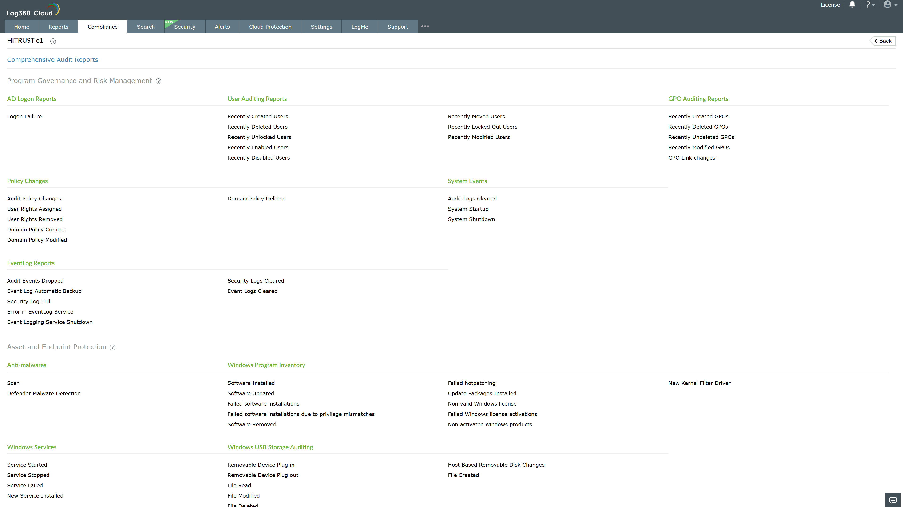
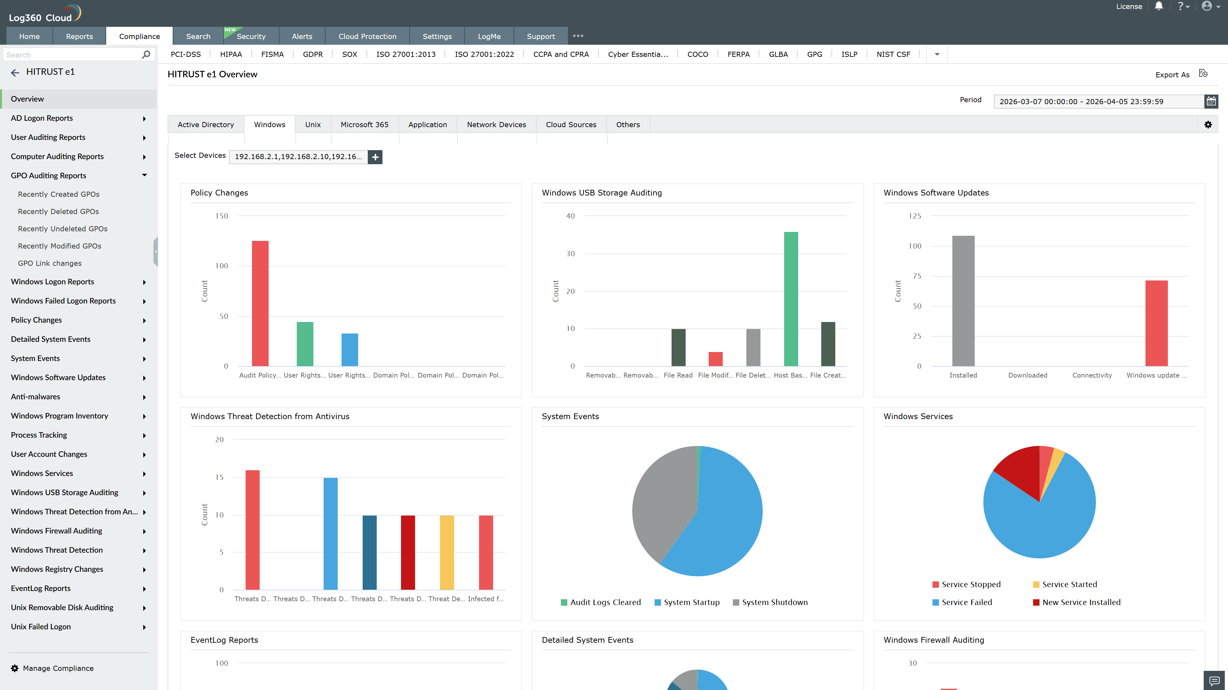
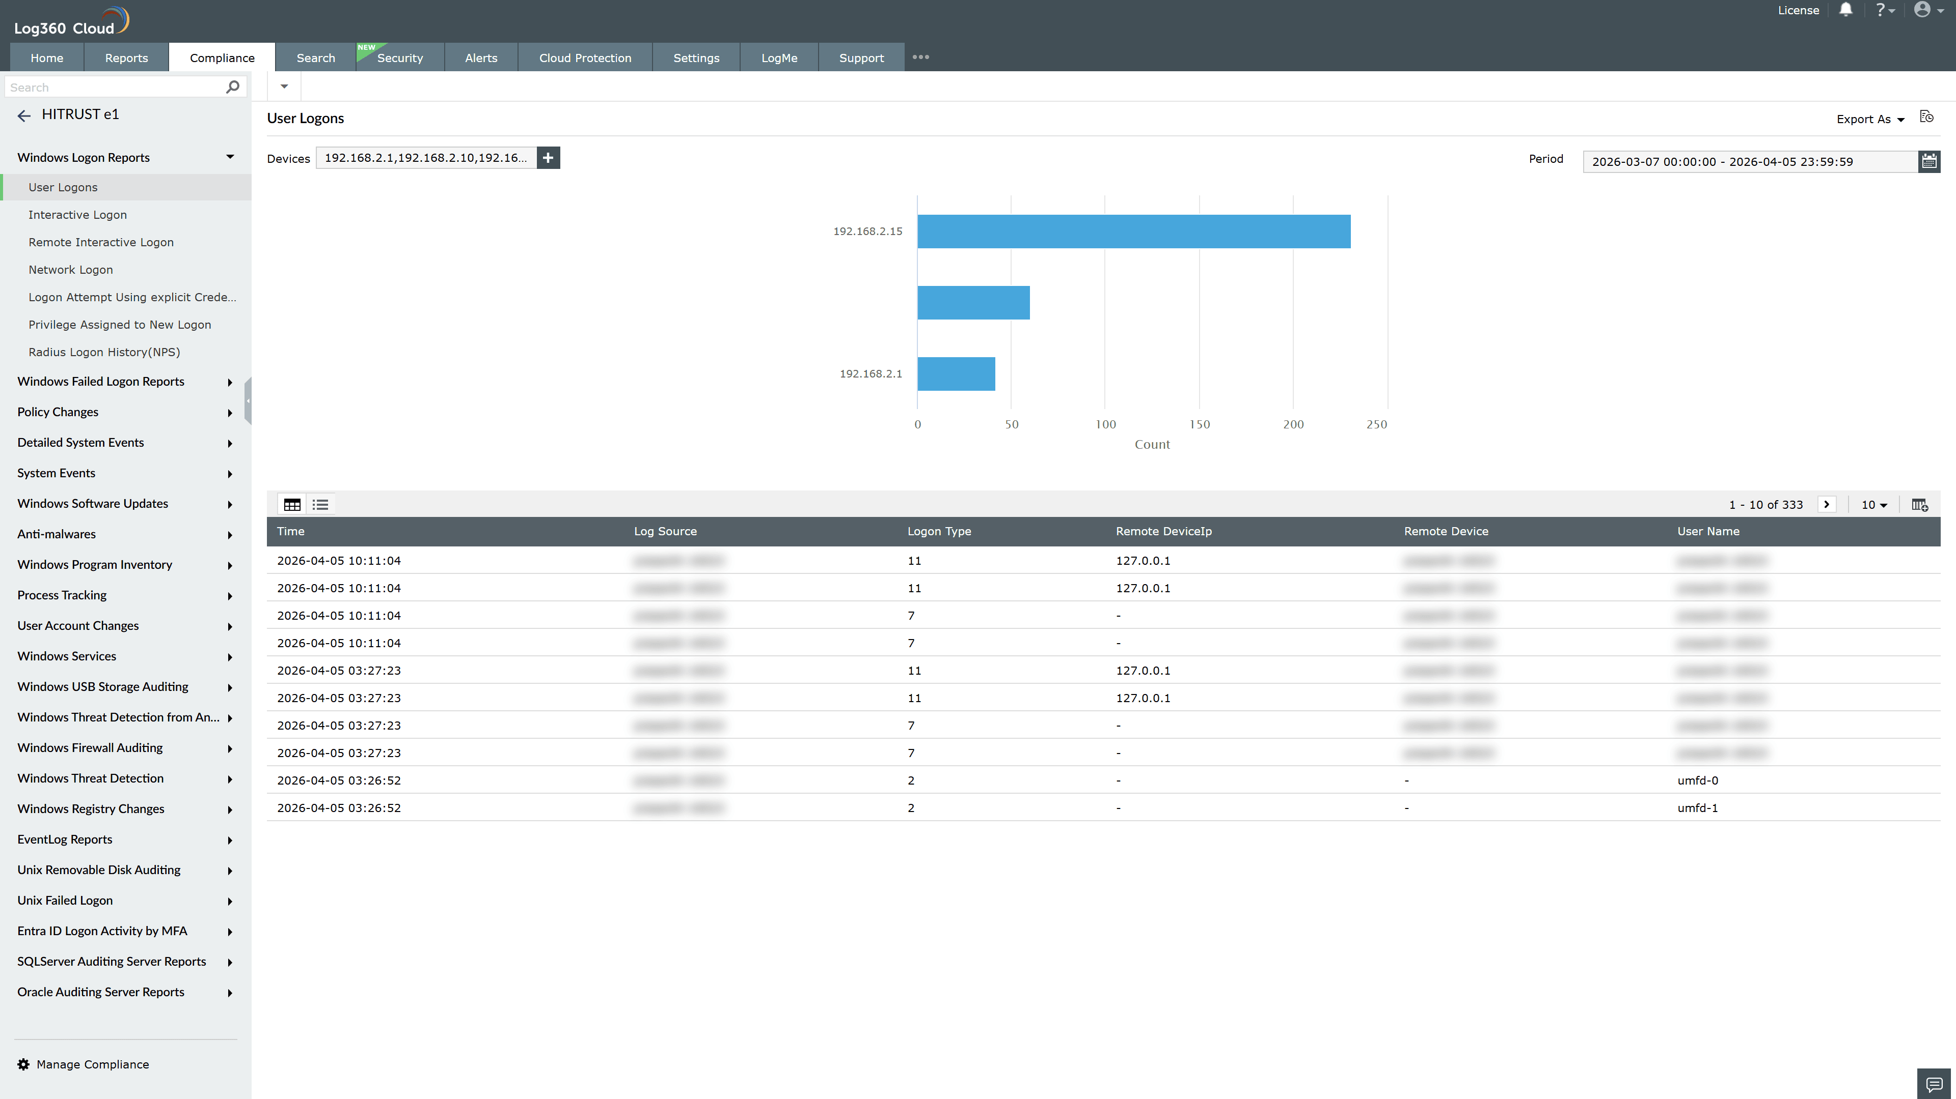
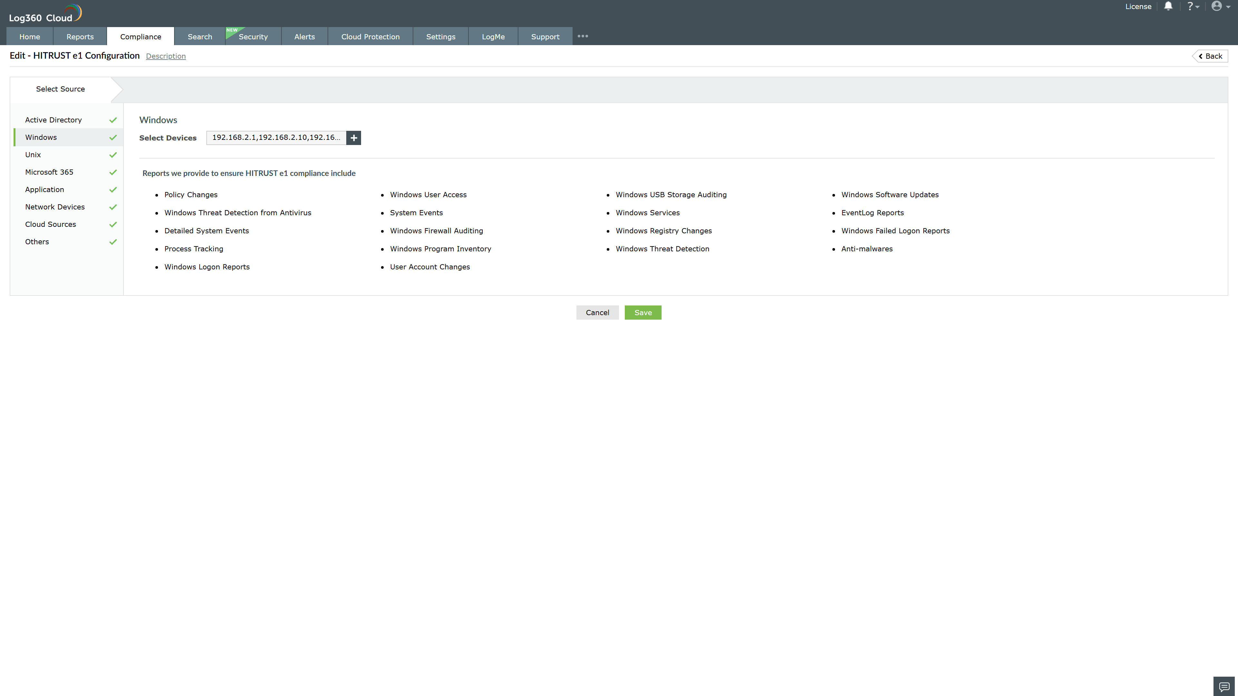
Valid Submission : Yes
Supported Editions : Free, Basic, Standard, Professional, MSSP
Help Document : https://www.manageengine.com/log-management/help/integrations/compliance-extensions.html
Help Video : Not provided
Tags : Log360, Compliance, Privacy monitoring, Data privacy, Regulatory compliance
Supported DCs : US, IN, JP, CA, AU, UK and EU
Privacy Policy:
Terms of Service:
Release Notes:
Predefined reports for the HITRUST e1.

